**EUROPEAN UNIVERSITY OF LEFKE**

FACULTY OF ENGINEERING

Graduation Project I

BUG TRACKER

Brendan Chukwudi Chukwuemeka

194192

A bug tracker application that enables development teams to receive bug reports from customers, assign tasks to staff for resolution and monitor progress. Customers can also track the progress and solution plans of these reports leading to a more transparent system.

28th of December, 2022.

Table of Contents

Name Surname**i**

Student Number**i**

Publish Date**i**

1. Introduction**1**

1.1 Problem Definition**1**

1.2 Goals**2**

Use case diagram**3**

2. Literature Survey**4**

3. Background Information**5**

3.1 Required software**5**

3.2 Other software**5**

4. Modules**6**

4.1 Admin module**6**

4.1.1 Add/remove/modify details of project and staff **6**

4.1.2 Viewing User Complaints**6**

4.1.3 Assigning Tasks to Staff**6**

4.1.4 Track bug resolution status**6**

4.2 Staff Module**6**

4.2.1 Viewing assigned tasks**7**

4.2.2 Transfer tasks to a different member**7**

4.3 User Module**7**

4.3.1 Issue a complaint**7**

4.3.2 View bug resolution progress and solution plan**7**

5. Risk Analysis **8**

6. Ethics **9**

7. Conclusion **10**

7.1 Benefits **10**

a. Benefits to users **10**

b. Benefits to me **10**

Reason for choosing this project**10**

7.2 Future works**10**

8. REFERENCES**11**

**Introduction**

* 1. **Problem definition**

Issues seem to always come up in finished products or systems irrespective of quality, amount of time sank into the project, amount of project revisions or technical ability of the developer(s).

Issues can arise as a result of failure of the product to fulfill the tasks for which it was acquired, temporary malfunctions or glitches in the system, confusion from customers as to the use of the products, design choices, etc.

Customers are usually the ones to take notice of these issues and want them to be fixed as fast and in as personalized a manner as possible, the developers would also like to fix these issues as soon as possible as negative product reviews from customers sets a negative image for the company. It is also in the best interest of a company to personalize these solutions as suggested by a 2018 report from Epsilon, a leading marketing company, that specializes in outcome-based marketing which showed that 80% of customers are more likely to do business with a company if it offered personalized experiences [1].

However, using tools such as email, direct phone calls or social media won’t suffice as they are slow, inefficient and a particularly busy period can quickly overwhelm the response team and lead to bottlenecks. And as such the need arises for a platform which enables customers to communicate their complaints and lets the developer(s) view and efficiently allocate resources to the resolution of the complaints while letting the customer see that their issues are being addressed.

There are products in the market as well as methods that businesses have devised to deal with this however most are either very specialized methods that are designed especially for the business or the major focus is on staff-staff interaction while solving the bugs with little to no customer input.

This project aims to addresses these shortcomings by creating a platform that is general enough that any development team can use it and flexible enough to be tailored to their needs and specifications; while adding a customer personalization feature.

**1.2 Goals**

* A major goal of this project is to create a general platform, this means that it will serve as a catch all platform for any development team in need of a robust bug tracking system that also enables them to interact and personalize customer bug submission and resolution experiences. This generality will not come at the cost of flexibility as this project will be versatile enough to let individual teams tailor their experiences.
* In addition, this project aims to facilitate the bug resolution process for the team(s) by providing features such as the ability to view problem resolution progress, issue ranking, issue assignment, communication lines, etc. in an easy-to-use interface that simplifies and expedites the process.
* This project also aims to enable a more effective and transparent bug reporting and monitoring process for users by providing a platform which allows them to directly report bugs and complaints and view the progress of its resolution.

**USE CASE DIAGRAM**

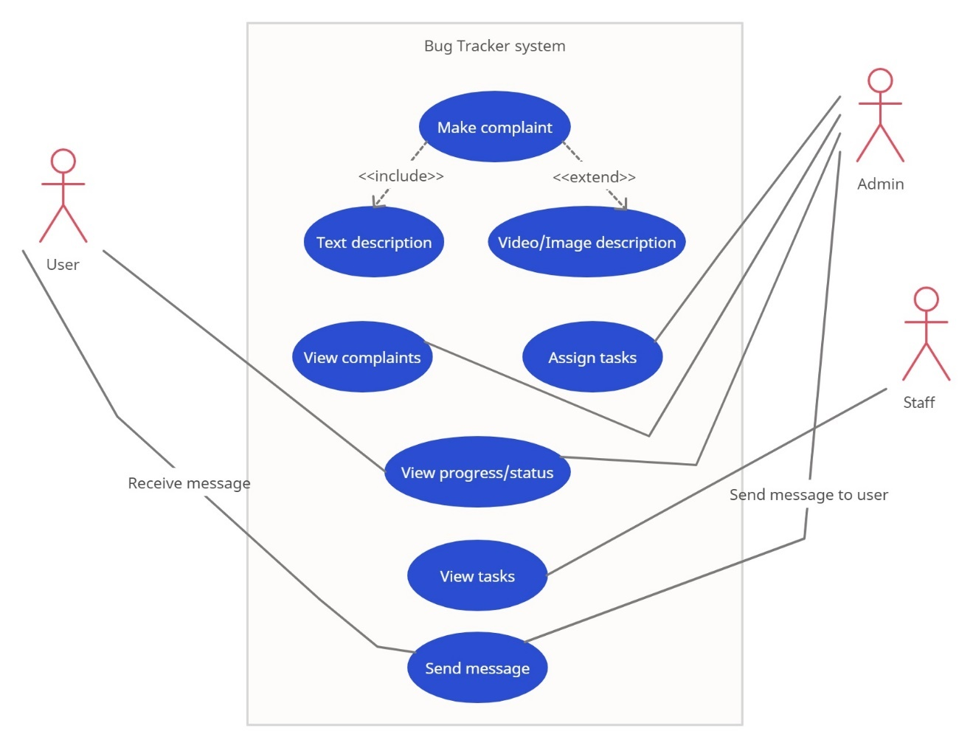

**2. Literature Survey**

Over time, numerous methods have been created and adopted by development teams for bug tracking purposes, these methods have significantly improved the way bugs are tracked and resolved however, there are issues with these methods or lack of features that this project seeks to address. In addressing these issues, three popular bug tracking systems will be analyzed and compared to this project namely Google’s issue tracker, Zoho bug tracker and Live agent.

**Issue tracker by Google:** Introduced in March of 2017, Google’s Issue is a tool used for reporting [2] and tracking bugs and feature requests during product development at Google [3]. It is not publicly available for use as a consumer product and there are several restrictions placed on its use [3]. It offers features that allow users to create issues, view tasks assigned to them and communicate with other staff. This however is a case of specialized software as this tool is intended solely for google authorized users and partners [3] required a certain level of technical ability and there is no feature to let the general public and users of Google products report bugs or view bug resolution progress.

This project on the other hand will be a more general product which in addition to enabling quality bug tracking will add features that will enable customer bug reporting and communication.

**Zoho bug tracker:** Created by Zoho Corporation Private Limited, Zoho bug tracker is a general-purpose bug tracking software that enables teams to create issues, assign issues to staff, view the progress of bug resolution and also provides various miscellaneous functions at the user interface and features level that assist in team management such as time tracking. A major shortcoming of this software and one which this project seeks to address is the opaqueness of the bug resolution process to the consumers. Users have no easy way of monitoring the progress of their bug reports or viewing the solution plan either as the only way they can be sure they are being attended to is if they are contacted by the staff by email, potentially long wait line chats, social media or phone.

**Live Agent:** Established in 2006, live agent is the most popular help desk and is often rated as the number one issue tracking software on the market due to its many features in addition to its bug tracker. Like Zoho bug tracker above, it provides features for creating and assigning issues, it also allows for progress monitoring and also like Zoho bug tracker it falters in its inability to let customers consistently view progress of their bug reports or solution plan to deal with the bug. It only provides a standard communication stream where customers can only have one off conversations with staff regarding their issues.

**3. Background Information**

**3.1 Required software**

* **Flutter:**

Flutter is an open source, cross platform, software development kit created by Google. I will be using flutter due to its ability to create beautiful and capable cross platform applications. It has very comprehensive documentation. Its use is also very widespread leading to lots of accessible resources and a great community.

* **Android studio:**

Android studio is the IDE (Integrated development environment) I will use due to it having official support by flutter, being the official IDE for the android operating system and its ease of use.

* **MySQL:**

MySQL is my database of choice due to its ease of use, ability to handle complex queries and simple integration with flutter applications.

**3.2 Other software**

**Git:**

I will use the git version control system because it’s a very capable and popular version control system.

**4. Modules**

**4.1 Admin Module**

The admin has to log into the system with special username and password associated with the admin view that allows them to access their accounts. Once in, they see their profile and dashboard which shows a list of new complaints created by users, they will also be able to see the status of bugs currently being addressed, assign tasks to staff, there will be an option to add or remove details of staff members as well as create new project or modify existing project details.

**4.1.1 Add/remove/modify details of project and staff**

The admin will be able to create the project page. As well as add the details of individual staff members. They are also able to delete and modify all this in

**4.1.2 Viewing User Complaints**

Once the admin clicks on a user complaint, they are able to read details of the complaints provided by the user and are able to determine the severity of the complaint which they can then tag using a variety of descriptions. They are also able to send a message to the user such as one to let them know their report has been viewed.

**4.1.3 Assigning Tasks to Staff**

Once the admin views the complaints, they are also able to view status of staff members to determine if they are free or working on a lesser impact problem. Once they determine their status, they are then able to either add staff members to a team and then assign them the tasks or assign the task to an individual. They can also activate the bug resolution meter which serves as a graphic oriented method to monitor progress.

**4.1.4 Track bug resolution status.**

The admin will also be able to access a section where they can view bugs being addressed. This section will show the amount of work done and the amount of work left to be done as well as specifics such as solution plan.

**4.2 Staff Module**

After staff members receive their login details from the admin, they are then able to sign into the system. Once in, they see their profile and dashboard which shows a list of their newly assigned tasks as well as tasks they are currently working on.

**4.2.1 Viewing assigned tasks**

Staff can view their newly assigned tasks immediately they sign in, if any of the tasks are entered, they can view more details about the tasks such as information on the bug and team member(s) if any.

**4.2.2 Transfer tasks to a different member.**

If the staff is unable to resolve a bug, a feature exists that enables them to transfer the task to a different staff with comments describing the problem.

**4.3 User Module**

Users access the platform by signing up using their name and email and setting a password. They can then look for the project in the database and once they find it, they can then submit a bug complaint. They can also see the progress status of their bug complaints as well as view solution plan details.

**4.3.1 Issue a complaint**

Once the user is on the project page, they can access a feature which lets them submit a bug complaint complete with full description of their complaint i.e., title and text, video, pictures of their complaint. Once done the complaint will be issued a unique ticket number.

**4.3.2 View bug resolution progress and solution plan**

On the user dashboard, they are able to see all of their reports ranked according to unattended, being resolved and resolved; and access them to see additional details. The user is also able to see the solution plans for reported bugs that have been resolved or are in the process of being resolved.

**5. Risk Analysis**

* **Unanticipated competition:** Since a major aspect of this project is to fill the space in the market for capable bug trackers with customer interaction and personalization feature, a major brand deciding to implement this in their won project can pose a significant risk to the adoption of this project.
* **Intellectual property rights:** Some features implemented in the project may be patented or copyrighted ideas that need to approved before application. This poses a risk to the project as it can significantly extend product development time and rejection of request to apply the feature could significantly slow down pace of development or even grind it to a halt.
* **Issue with support software:** Issues with software used to build this project could jeopardize the success of this project. For example, an exploit found in the database system I will be using (MySQL) could cause malfunctioning of the project.
* **Extended development period:** Development and testing of this project’s features could take more time than expected.
* **Slow adoption:** It might result that there really isn’t a market or need for the new features which this project provides, there might also be an unforeseen reason why people would not want to use the system. Slow adoption could give more time for already established competitors to apply the new features into their own and thereby causing this project to lose its first mover advantage.

**6. Ethics**

* **Data privacy:** Users of the software should be able to use the system with the assurance that their personal data is not being used for malicious purposes such as being sold to third parties without their express permission. In order to do this, the project has to follow established privacy policies such as the GDPR (General Data Protection Regulation) in EU member states and KVKK (Kişisel Verileri Koruma Kanunu) in Turkey.
* **Monitoring for extremists/ sanctioned companies:** In order to make the platform as safe as possible, measures should be in place to prevent extremist groups from joining the platform and remove them if they find their way in. Companies/groups/ individuals sanctioned by the international community should also not be allowed on the platform such as ones that support the 2022 Russian invasion of Ukraine.
* **Prevention of Brand Impersonation:** Brand impersonation means entities falsely identifying themselves as a well-known brand usually for malicious purposes. There should be measures such as brand authentication put in place to such activity to a minimum.

**7. Conclusion**

**7.1 Benefits**

**a. Benefits to users**

**1.** Reducing bottleneck situations for development teams by letting them quickly and efficiently receive, assign, monitor and resolve tasks/bugs.

**2.** Customers with complaints will be able to effectively communicate these complaints to development teams.

**3.** Creating a more transparent bug resolution process for users.

**b. Benefits to me**

**1.** I will learn intuitive user interface design

**2.** Expanding and reinforcing my knowledge on Database management systems and querying a database

**3.** Gain a good grasp of the flutter software development kit and the dart programming language.

**Reason for choosing this project:**

I chose this project because it struck a good balance between being demanding enough to require a lot of effort and research and being a doable project; while providing a genuinely useful tool that has the potential to facilitate the product development process for teams.

**7.2 Future works**

I intend to carry on working on this project after graduation due to its potential, Improvements can be made to the overall security of the platform by implementing modern cryptographic techniques such as 2-factor authentication, I also intend to integrate a specialized artificial intelligence model that learns patterns of users and serves as an assistant, Also an AI chatbot feature that will serve as the first phase of communication with the consumer incase their reports are trivial and can be solved easily.

**8. REFERENCES**

[1] Epsilon. (2018, Jan. 9). *New Epsilon research indicates 80% of consumers are more likely to make a purchase when brands offer personalized experiences* [online]. Available: <https://www.epsilon.com/us/about-us/pressroom/new-epsilon-research-indicates-80-of-consumers-are-more-likely-to-make-a-purchase-when-brands-offer-personalized-experiences>

[2] R. Kovatch. (2020, Jan. 24). *Google Issue Tracker testing Material Theme redesign* [online]. Available: <https://9to5google.com/2020/01/24/google-issue-tracker-material-redesign/>

[3] Google developers. (2021, Dec. 10). *Google Issue Tracker* [online]. Available: <https://developers.google.com/issue-tracker>